Karel Makes Waves

Write a program that has Karel draw four small "waves". Each wave is a triangle made up of three beepers. There is a gap between each wave. When karel is done the world should look like this:

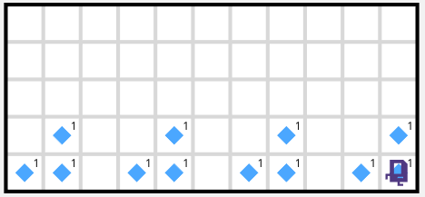

Concepts:

This problem reviews basic control flow with Karel. It was much easier to solve if you defined a make_wave() function. It also introduces a fence-post problem where you need to move between waves three times, but you need to draw four waves. Chapters: [Decomposition Chapter](https://compedu.stanford.edu/karel-reader/docs/python/en/chapter4.html) and the Fencepost bug part of the [While loop chapter](https://compedu.stanford.edu/karel-reader/docs/python/en/chapter6.html).

Example Solutions



1

2

3

4

5

6

7

8

9

10

11

12

13

14

15

16

17

18

19

20

21

22

23

24

25

26

27

28

29

30

31

32

33

34

35

36

37

38

39

"""

There are many solutions to this problem. Here are a few

"""

# Example Solution 1

def main():

# make the first three waves

for i in range(3):

build_wave()

# you need to move twice to go between waves

move()

move()

# because of the fencepost bug, we need a fourth wave

build_wave()

def build_wave():

put_beeper()

move()

put_beeper()

turn_left()

move()

put_beeper()

turn_around()

move()

turn_left()

# Example Solution 2

def main():

# you can also solve this problem with a while loop

while front_is_clear():

build_wave()

# you might be facing a wall at this point!

if front_is_clear():

move()

move()

def build_wave():

# same as in solution 1

What did the AI Think?

An algorithm read your program. It has some ideas! But you should take them with a grain of salt. Algorithms aren't as smart as people! Check out what the AI said to unlock the next question!

See your solution